**APLIKASI MONITORING DAN PENILAIAN KINERJA PENGEMBANGAN TALENT PT.POS INDONESIA (PERSERO)**

**( STUDI KASUS : DIVISI TALENT MANAGEMENT )**

Laporan ini dibuat untuk memenuhi persyaratan kelulusan

matakuliah Program Internship I

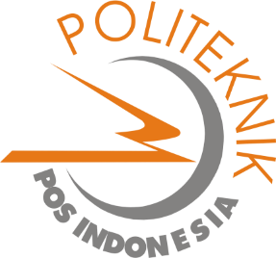

**Dibuat Oleh,**

**1.16.4.072 Fadila**

**PROGRAM DIPLOMA IV TEKNIK INFORMATIKA**

**POLITEKNIK POS INDONESIA**

**BANDUNG**

**2020**

**APPLICATION OF MONITORING AND ASSESSMENT OF TALENT DEVELOPMENT PERFORMANCE OF PT. POS INDONESIA (PERSERO)**

**( STUDY CASE : TALENT MANAGEMENT DIVISION )**

*This report submitted to fulfill the requirements for Internship Program*



***Created by,***

**1.16.4.072 Fadila**

***APPLIED BACHELOR PROGRAM OF INFORMATICS ENGINEERING***

***POLITEKNIK POS INDONESIA***

***BANDUNG***

***2020***